Ideation Phase Empathize&Discover

Date | 19February 2026
TeamID | LTVIP2026TMIDs66458
ProjectName | GeminiHistoricalArtifactDescription
MaximumMarks | 4 Marks

EmpathyMap Canvas:
Anempathymapisasimple,easy-to-digestvisualthatcapturesknowledgeaboutauser’s
behavioursandattitudes.

Itisausefultooltohelpsteamsbetterunderstandtheirusers.
Creating an effective solution requires understanding the true problem and the person who is experiencing it. The exercise of creating the map helps participants consider things from the user’s perspective along with his or her goals and challenges.

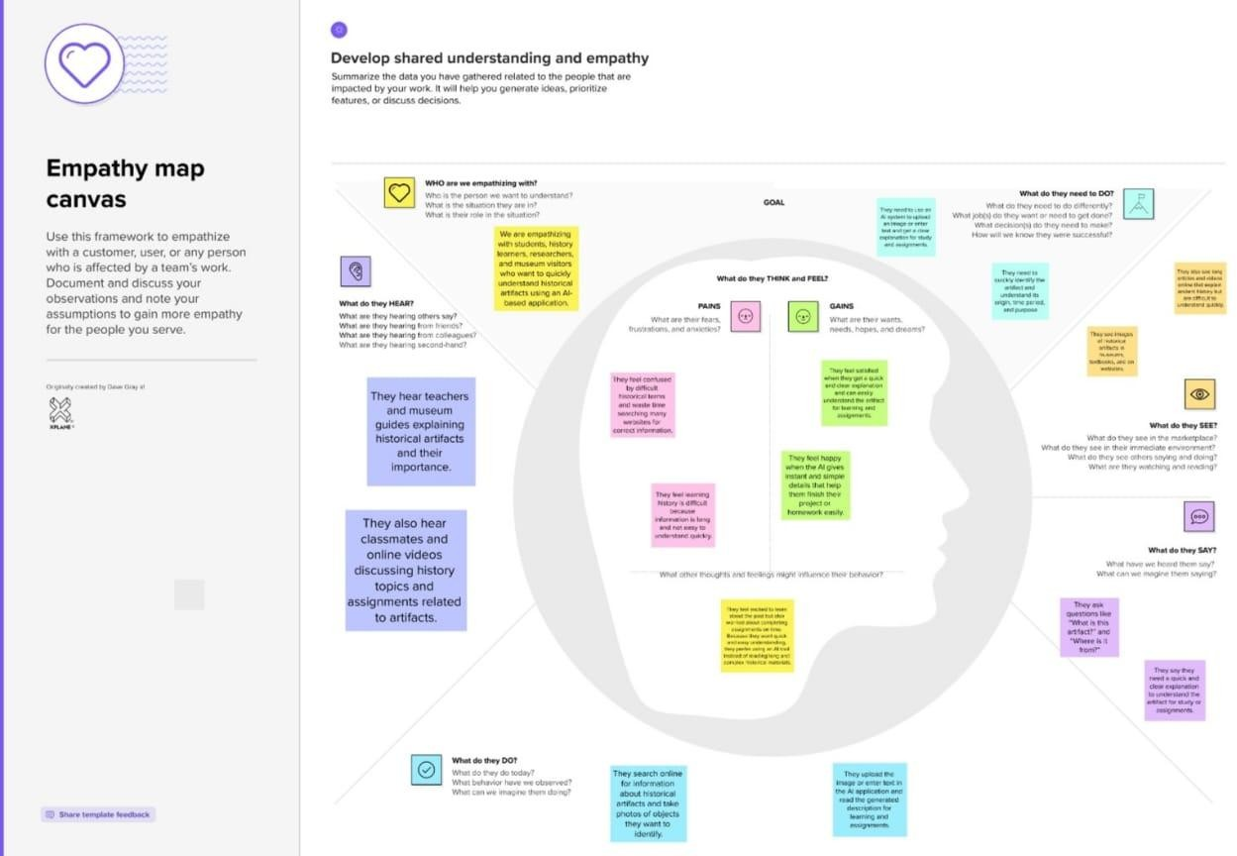
Example:GeminiHistoricalArtifactDescription

